**NAAN MUDHALVAN PROJECT**

 

**MEENAKSHI SUNDARARAJAN ENGINEERING COLLEGE**

Kodambakkam, Chennai-600024.

# DEPARTMENT OF INFORMATION TECHNOLOGY

**TOPIC: Competitive Analysis of Leading Travel Aggregators**

TEAM ID : NM2023TMID07286

FACULTY MENTOR : Mrs. K .Nandhakumari

INDUSTRY MENTOR :Shivam Shivhare

Project submitted by,

|  |  |  |
| --- | --- | --- |
| **TEAM** | **NAME** | **REG. NO.** |
| Team Leader | Deepthi M R | 311520205009 |
| Team mate 1 | Shivani R | 311520205043 |
| Team mate 2 | Devatha S | 311520205010 |
| Team mate 3 | Sanjula T N | 311520205041 |
| Team mate 4 | Srividhya P | 311520205046 |

**ABSTRACT :**

The advent of travel aggregators—online platforms that compile data from multiple sources to give users a comprehensive picture of available travel options—has significantly changed the travel business. The purpose of this investigation is to learn more about the function and significance of travel aggregators in the market. This paper offers a thorough knowledge of these platforms by looking at their characteristics, operations, market trends, and ramifications for various stakeholders, such as suppliers, traditional travel agents, and travelers.Starting with a market overview, the report assesses market share, growth patterns, and leading players. It investigates the fundamental business plans and methods used by travel aggregators, looking at methods for generating income, supplier relationships, and consumer interactions. Customer support services, booking procedures, and website interfaces are all evaluated in terms of user experience and features. Benefits and drawbacks for travelers, suppliers, and conventional travel agents are taken into account when assessing the effect of travel aggregators on the travel sector. This analysis sheds light on client loyalty, distribution routes, and pricing. Personalized recommendations, the integration of artificial intelligence, sustainability programs, and technical improvements are among the other rising themes that are noted.The analysis's conclusions add to a thorough knowledge of travel aggregators' performance and competitive environment. Travelers gain from improved user experiences, and businesses may make well-informed decisions about marketing tactics and collaborations. Furthermore, to maintain their competitiveness in the ever-evolving travel sector, stakeholders can adjust to changes and take advantage of new trends.All things considered, this Travel Aggregator Analysis provides insightful information about the changing landscape of travel for both businesses and consumers.

**Project Report Format**

# INTRODUCTION

* 1. Project Overview
  2. Purpose

# LITERATURE SURVEY

* 1. Existing problem
  2. References
  3. Problem Statement Definition

# IDEATION & PROPOSED SOLUTION

* 1. Empathy Map Canvas
  2. Ideation & Brainstorming
  3. Proposed Solution
  4. Problem Solution fit

# REQUIREMENT ANALYSIS

* 1. Functional requirement
  2. Non-Functional requirements

# PROJECT DESIGN

* 1. Data Flow Diagrams
  2. Solution & Technical Architecture
  3. User Stories

# PROJECT PLANNING & SCHEDULING

* 1. User Stories

# CODING & SOLUTION (Explain the features added in the project along with code)

* 1. Feature 1
  2. Output

# TESTING

* 1. Test Cases

# RESULTS

* 1. Performance Metrics

# ADVANTAGES & DISADVANTAGES

1. **CONCLUSION**
2. **FUTURE SCOPE**
3. **APPENDIX**

GitHub & Project Demo Link

# INTRODUCTION

The way individuals organize and reserve their trip has been completely transformed by travel aggregators. These internet resources allow consumers to compare costs, availability, and reviews in one location by compiling data from a variety of sources, including hotels, airlines, rental car companies, and tour operators. Analyzing travel aggregators has become essential for both businesses and travelers as the travel industry grows and becomes more competitive. Examining the function and significance of travel aggregators in the travel sector is the aim of this investigation. We want to obtain understanding of their advantages, difficulties, and consequences for different stakeholders by examining their features, operations, and market trends. This research will provide us a thorough grasp of the travel aggregator market, enabling us to assess their efficacy, spot new trends,

# PROJECT OVERVIEW

By conducting a thorough analysis of travel aggregators, we aim to provide valuable insights for businesses looking to optimize their presence in the industry and for travelers seeking the best options for their travel needs. Understanding the evolving landscape of travel aggregators will enable stakeholders to adapt, innovate, and make informed decisions in this dynamic and highly competitive market.

# PROJECT FLOW

1. **Project Initiation**
   1. Define the scope and objectives of the analysis.
   2. Establish the timeline and allocate resources for the project.
   3. Formulate the research questions and key areas of focus.

# Data Collection and Research

* 1. Gather relevant data from various sources, including industry reports, market research, and academic studies.
  2. Collect data on travel aggregator platforms, their features, business models, and market performance.
  3. Conduct interviews or surveys with industry experts, travelers, and suppliers to gather qualitative insights.

# Market Overview

* 1. Analyze the current state of the travel aggregator market.
  2. Identify and evaluate major players in the industry.
  3. Assess market share, growth trends, and regional variations.
  4. Examine factors influencing the competitive landscape.

# Business Models and Operations

* 1. Explore the underlying business models of travel aggregators.
  2. Analyze revenue generation strategies and profitability.
  3. Investigate partnership models with suppliers, including airlines, hotels, car rental agencies, and tour operators.
  4. Examine customer acquisition and retention strategies.

# User Experience and Features

* 1. Evaluate the user experience provided by travel aggregators.
  2. Analyze website interfaces, mobile applications, and user interfaces.
  3. Assess search capabilities, filtering options, and sorting features.
  4. Examine the booking process, payment methods, and customer support services.
  5. Identify innovative features and functionalities that enhance the user experience.

# Impact on the Travel Industry

* 1. Assess the impact of travel aggregators on different stakeholders:
  2. Travelers: Evaluate the benefits, convenience, and potential drawbacks of using aggregators.
  3. Suppliers: Analyze the influence on pricing, distribution channels, and relationships with suppliers.
  4. Traditional travel agents: Examine the effects on brick-and-mortar travel agencies and their adaptation strategies.

# Analysis and Findings

* 1. Consolidate and analyze the data collected.
  2. Identify patterns, trends, and correlations in the findings.
  3. Interpret the data to derive meaningful insights.
  4. Draw conclusions based on the analysis.

# Report Writing and Presentation

* 1. Prepare a comprehensive report summarizing the analysis, findings, and recommendations.
  2. Structure the report in a logical and organized manner.
  3. Create visual aids and graphs to support the findings.
  4. Present the report to stakeholders, highlighting key points and answering questions.

# PURPOSE

An analysis of travel aggregators is conducted to obtain a thorough grasp of the function and significance of travel aggregators in the travel sector, It entails researching these platforms' features, functions, and market trends as well as the ramifications they have for different travel industry players like suppliers, traditional travel agencies, and passengers.

# LITERATURE SURVEY

**EXISTING PROBLEM AND REFERENCES 2018**

**Title:** Competitive Analysis of Indian Tourism Aggregators Using Multi-Criteria Analytic

Hierarchy Process

**Published in**: 2018

**Authors**: Mihir Dash, Kshitiz Sharma

The aim of this research is to assess the competitiveness of Indian tourism aggregators through the application of the Analytic Hierarchy Process (AHP). AHP is a method that facilitates the systematic evaluation of multiple criteria, enabling a comprehensive analysis of both quantitative and qualitative aspects of various alternatives (Saaty and Forman, 1992; Saaty, 2008). The criteria considered in this study encompass factors like pricing, operational procedures, accessibility, and customer service. The tourism aggregators under scrutiny in this research are Yatra, Makemytrip, Goibibo, Cleartrip, Expedia, and Kuoni-SOTC.

**2022**

# Title : Accessibility and readability of website: An analysis of Online Travel Aggregators (OTAs) of India

**Published in**: 2022 .

**Authors:** Ranjit Singh, Sibi P.S.

## This research investigates the accessibility and readability of online travel agency (OTA) websites in India. The accessibility aspect was evaluated based on compliance with the Web Content Accessibility Guidelines (WCAG), while readability was assessed using two different indices. To gain insights into user behavior patterns, the study employed a 4C approach, involving Cluster tendency, Cluster number, Cluster analysis, and Cluster validity within k-means cluster analysis. The study revealed significant issues with OTAs' websites in terms of WCAG compliance and identified challenges related to the readability of the website content. These issues make it difficult for individuals with disabilities to effectively utilize these OTAs' websites. The findings lead to discussions about potential implications and recommendations for enhancing the accessibility and readability of these websites.

# IDEATION & PROPOSED SOLUTION

**Empathy Map Canvas**

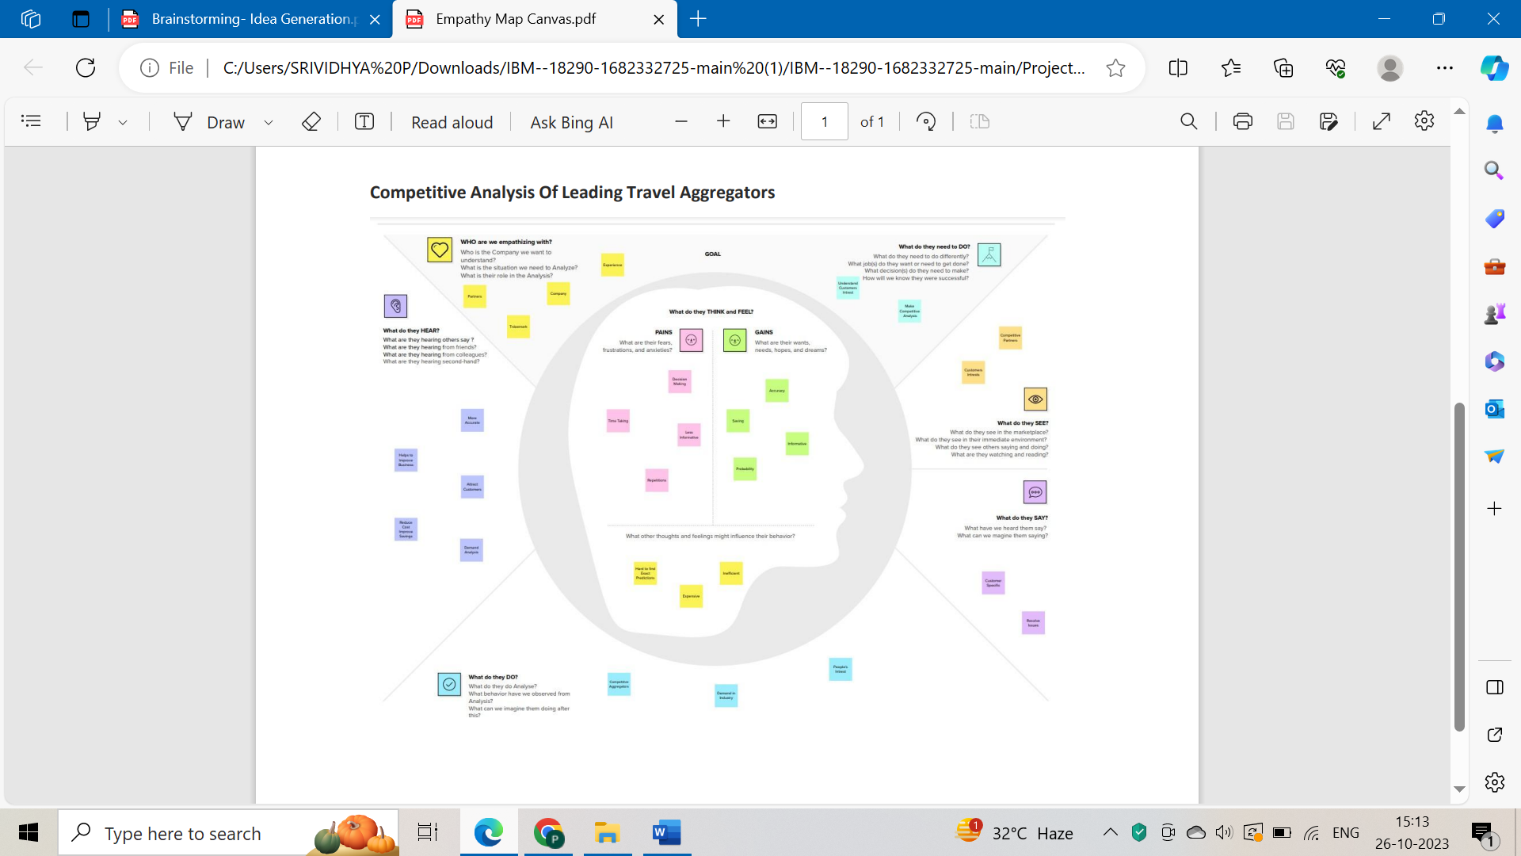

# Ideation & Brainstorming



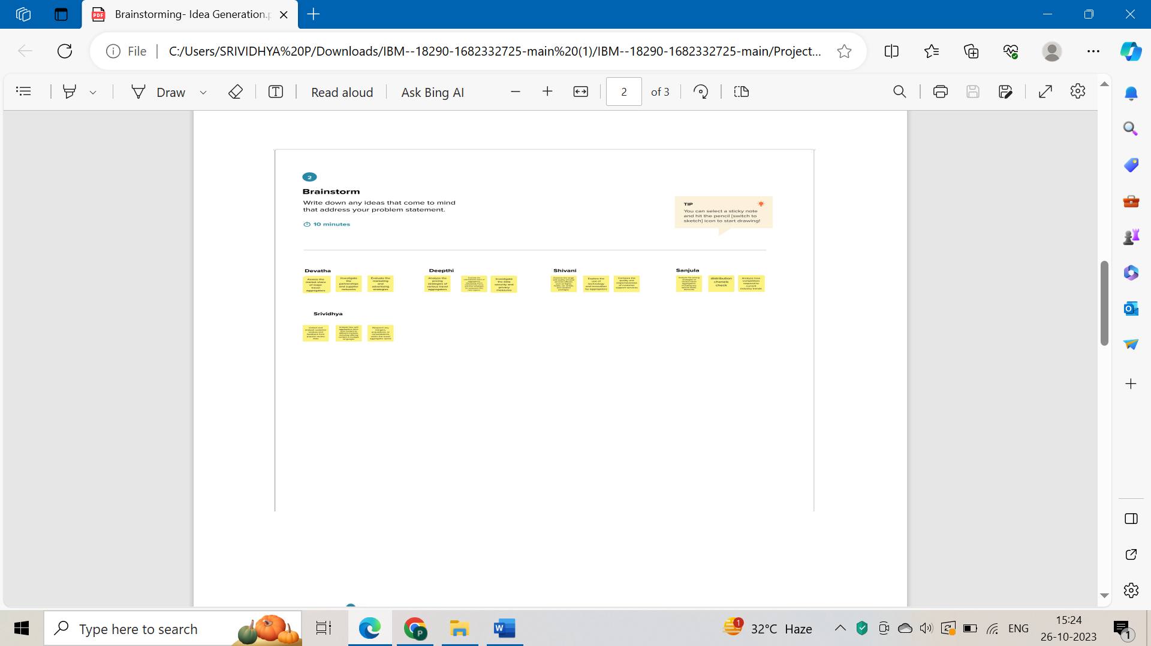



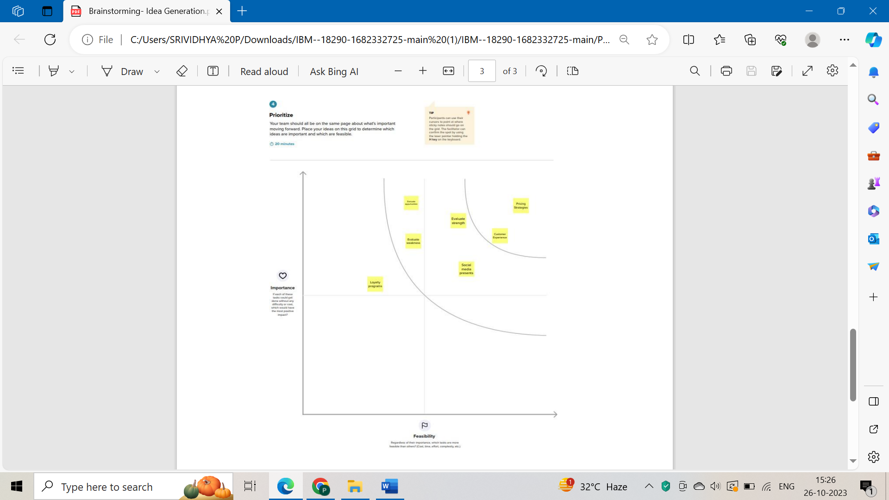

**PROPOSED SOLUTION**

|  |  |  |
| --- | --- | --- |
| **S.No.** | **Parameter** |  |
| 1. | Problem Statement | An online search engine or platform that lets consumers look up and contrast costs for travel- related goods and services—like hotels, airlines, vacation rentals, and vehicle rentals—from several suppliers are referred to as a travel aggregator. In addition to offering additional amenities like reviews, ratings, and images to aid in decision-making, travel aggregators usually give customers an easy and efficient way to search for and reserve vacation-related goods and services. Expedia, Booking.com, Kayak, and Trivago are a few notable examples of travel aggregator websites. Typically, travel aggregators offer commissions or fees to the travel companies who sell the products and services that are listed on their platform in order to make money. Some make money from advertising as well as from offering other services like vehicle rentals or travel insurance. Utilizing a travel aggregator can be an excellent method to learn regarding consumer preferences, industry trends, and the effects of outside factors. This can be accomplished through examining the travel aggregator's data, which may be used to generate insights and make data-driven decisions. This data includes bookings, reviews, prices, and other pertinent data. |
| 2. | Solution description | The objective of this competitive analysis is to identify best practices and areas for improvement related to user experience and customer satisfaction among travel aggregators.  This analysis will help travel aggregators better understand their competitive landscape and make data-driven decisions to enhance their services. .  Selection of Competitors: Identify a set of key competitors in the travel aggregator industry, including both global and regional players. . .    User Experience Evaluation: Analyze the user interface and website/app experience of each aggregator, focusing on factors such as ease of use, speed, design, and overall userfriendliness. Conduct usability testing to identify pain points in the booking process. . .    Customer Support Assessment: Evaluate the quality and responsiveness of customer support services provided by each aggregator, including live chat, phone support, and email assistance. Gather customer feedback and analyze response times and problem resolution rates. . .  Localization and Personalization: Assess how well aggregators tailor their content to different markets, including offering content in multiple languages, adapting to local customs, and presenting relevant deals and destinations based on user profiles. . .  Innovative Features: Investigate the innovative features and technologies employed by aggregators, such as AI-driven recommendations, virtual reality tours, or personalized travel itineraries. . .  Competitor Response to Customer Feedback: Analyze how competitors respond to customer feedback and reviews on various platforms. Identify areas where competitors have made improvements based on customer input. . .  Comparison of Mobile Apps: Evaluate the functionality and user experience of mobile apps offered by each aggregator, considering factors like speed, user ratings, and features. . .  Data Security and Privacy: Assess the data security measures and privacy compliance of each aggregator to ensure the protection of customer information. |
| 3. | Novelty/Uniqueness | The solution covers all the essential steps needed to conduct an in-depth analysis of a travel aggregator, from defining the problem to implementing and evaluating the solution. Additionally, the solution emphasizes the importance of using data-driven insights to inform decision-making and develop solutions that are aligned with customer preferences and market trends. The solution also highlights the importance of data cleaning and preparation, which can be a time-consuming and challenging process, but is crucial for ensuring the accuracy and reliability of the analysis. By emphasizing the importance of data quality and data preparation, the solution provides a robust framework for conducting a thorough analysis of a travel aggregator. Overall, the uniqueness of this solution lies in its emphasis on the importance of data-driven decision-making and its comprehensive approach to analyzing a travel aggregator, which covers all the essential steps needed to developa solution that is aligned with customer preferences and market trends. |
| 4. | Social impact/  Customer satisfaction | Travel aggregators may improve the user experience through applying the insights they learn about customer preferences and behaviors from data analysis. Travel aggregators, for instance, can determine popular travel destinations, dates, and places to stay through examining data on customer searches and bookings. This information is then used to personalize their offerings to suit the needs of their customers. Second, data analysis can assist travel aggregators in fine-tuning their pricing strategies so they can provide customers with competitive and attractive prices. Travel aggregators can instantly modify their prices to stay competitive and maximize revenue by looking at data on pricing patterns and customer behavior. Thirdly, travel aggregators can find areas over growth and expansion with their help of data analysis. Travel aggregators can find new markets or products that could be of interest to their consumers by analyzing data on market dynamics and competitor performance, which can help to increase customer satisfaction and their customer base. In Final, analyzing data can provide travel aggregators with valuable insights that can be used to improve the user experience, optimize pricing strategies, and identify growth opportunities, all of which can contribute to enhancing customer satisfaction. |

|  |  |  |
| --- | --- | --- |
| 5. | Business/ Revenue model | Offering travel aggregators data analytics services, including data preparation, data cleaning, data analysis, and solution development, could be the business model for this solution. To enhance the travel aggregator's business performance, the solution development procedure could involve identifying key findings and formulating strategies to optimize pricing, enhance the user experience, and identify growth opportunities. There are two possible income streams for this business: project-based and subscription-based. The travel aggregator would pay a one-time fee for the consulting or data analysis services under the project-based model and a recurring fee for access under the subscription-based model. to ongoing data analytics or consulting services. Offering consulting or data analytics amenities to help a travel aggregator improve its business performance and user experience is a typical business model for assessing a travel aggregator. Project-based or subscription- based fees are the main sources of revenue, and additional services may be provided |
| 6. | Scalability of the solution | The scope and complexity of the data set, availability of technological resources, and the maximum amount of clients the service provider can handle are some examples of the factors that could affect the degree to which the travel aggregator evaluation solution is. The solution could be made more scalable in order to serve a larger number of consumers by utilizing technology and automating some aspects of it while emphasizing on providing high-level analysis and insights |

# REQUIREMENT ANALYSIS

# Functional Requirements:

Following are the functional requirements of the proposed solution.

|  |  |  |  |  |
| --- | --- | --- | --- | --- |
| **FR No.** | **Functional Requirement (Epic)** | | | **Sub Requirement (Story / Sub-Task)** |
| FR-1 | Performance Dashboard | | | Real-time data integration with the top travel aggregator system  Keep an eye on trends and evaluate how well various aggregators perform. |
| FR-2 | Report Generation | | | Clear presentation of data Data accuracy  Timeliness |
| FR-3 | User Portal | | | User-friendly interface Notifications and alerts |
| FR-4 | Aggregator Portal | | | Goal-setting tools Personalized information |
| FR-5 | Assessment and Evaluation Tool | | | Validity and reliability  Clear grading criteria Individualized feedback |
| FR-6 |  | Geo-location and Mapping: |  | Integration with mapping services for navigation and trip planning. |
|  | | |

# Non-functional Requirements:

Following are the non-functional requirements of the proposed solution.

|  |  |  |
| --- | --- | --- |
| **NFR No.** | **Non-Functional Requirement** | **Description** |
| NFR-1 | **Usability** | Usability is important in branch-level performance analysis because it influences user adoption, data accuracy, user satisfaction, efficiency, accessibility, training needs, collaboration, and decision-making. |
| NFR-2 | **Security** | Data protection, confidentiality, user authentication, data backup and recovery will  all be handled correctly. |
| NFR-3 | **Reliability** | Reliability ensures that the analysis's data and information are correct, consistent, and dependable. |
| NFR-4 | **Performance** | Performance in Branch Wise performance analysis is  to measure and evaluate how well a student is performing in a particular subject or skill area. |
| NFR-5 | **Availability** | The role of availability in Branch-wise performance analysis is to ensure that the required data and resources are accessible and reliable. |

effectiveness of maintaining the platform, Resource Utilization: Examine how efficiently

capacity and bandwidth.

system resources are utilized, such as server

including server and hosting expenses.

Infrastructure Costs: Analyze the cost-

**Cost and Resource Efficiency:**

NFR-6

**PROJECT DESIGN**

**Data Flow Diagrams**:

A Data Flow Diagram (DFD) is a traditional visual representation of the information flows within a system. A neat and clear DFD can depict the right amount of the system requirement graphically. It shows how data enters and leaves the system, what changes the information, and where data is stored.

**DFD LEVEL 0 :**

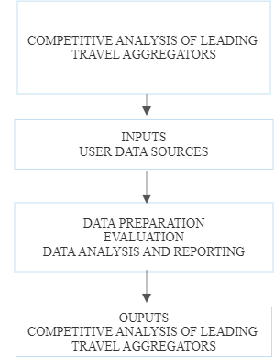

**DFD LEVEL 1:|**

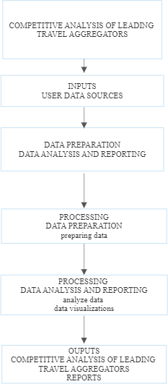

# DFD LEVEL 2 :

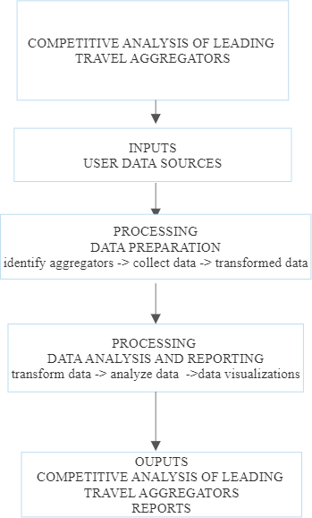

**SOLUTION AND TECHNICAL ARCHITECTURE SOLUTION ARCHITECTURE:**

Creating a solution architecture for the competitive analysis of leading travel aggregators involves designing a structured framework that outlines the components, technologies, and processes required to collect, analyze, and present the data and insights.

Here's an overview of the key components of a solution architecture for this purpose:

● Competitor Selection-Define a list of leading travel aggregators to analyze.

● Data Sources-Identify sources of data for competitive analysis, such as websites, mobile apps, APIs, social media, and third-party data providers.

● Data Warehouse- Set up a data warehouse for storing historical and real-time data for analysis.

● Data Security- Implement robust security measures to protect sensitive data and ensure compliance with data privacy regulations.

● Backup and Recovery- Implement a robust disaster recovery plan and ensure data redundancy to prevent data loss in case of system failures.

● Regular Maintenance- Schedule routine maintenance to ensure the solution's smooth operation and to address any issues that may arise.

● Updates and Upgrades- Keep software and technologies up to date to take advantage of the latest features and security

# TECHNICAL ARCHITECTURE:

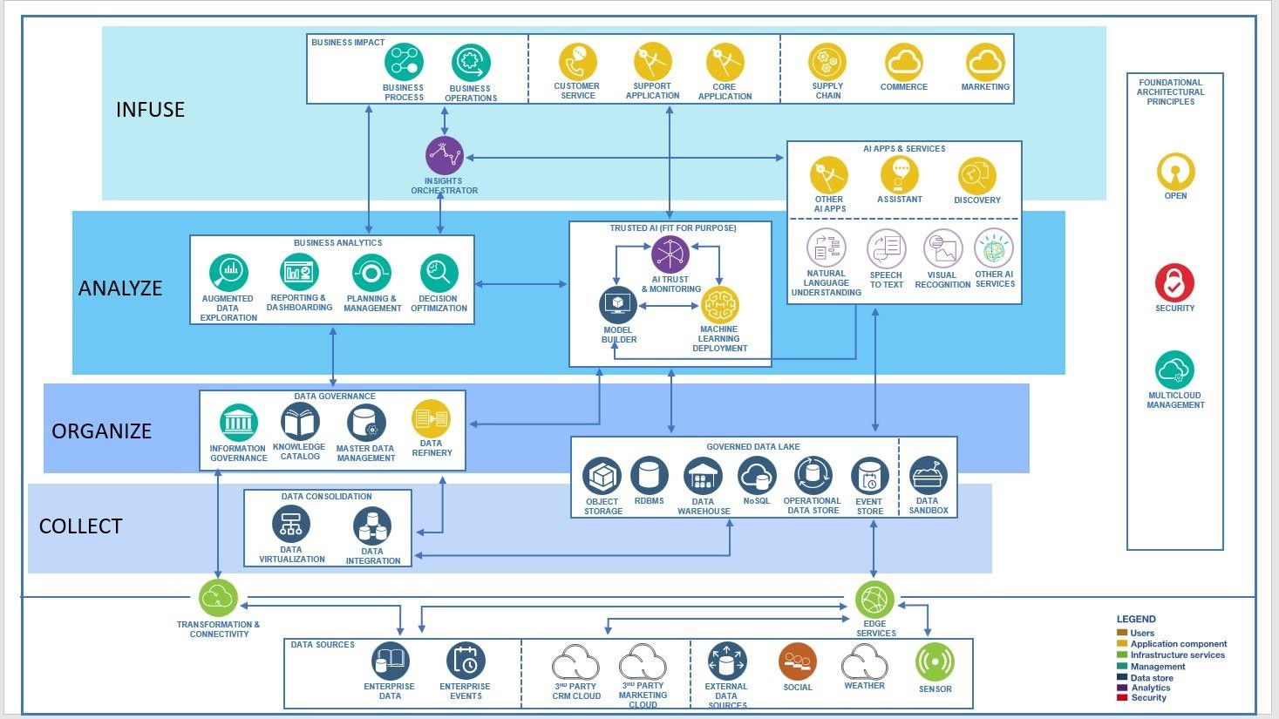

**Table-1 : Components & Technologies:**

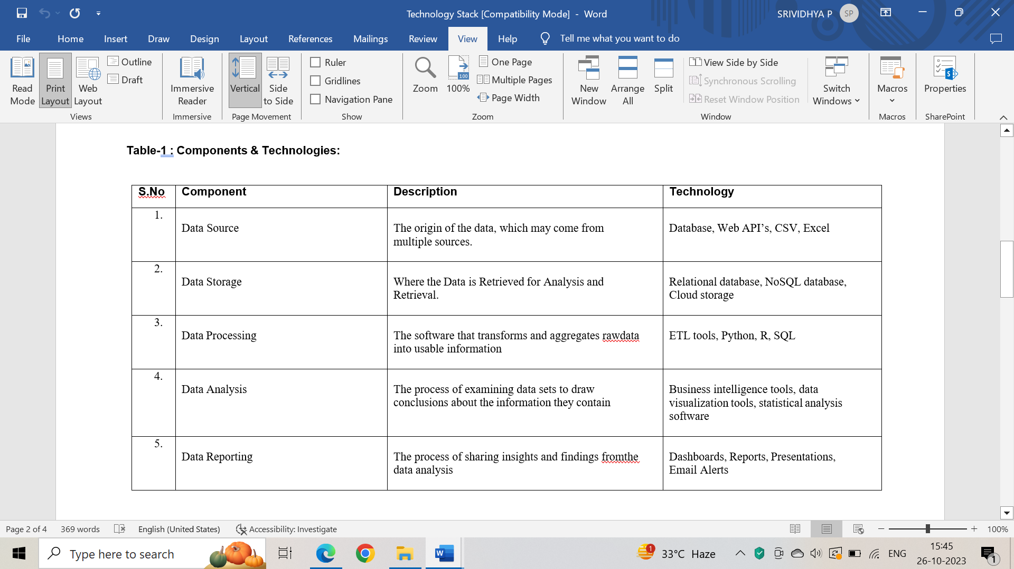



# Table-2: Application Characteristics:



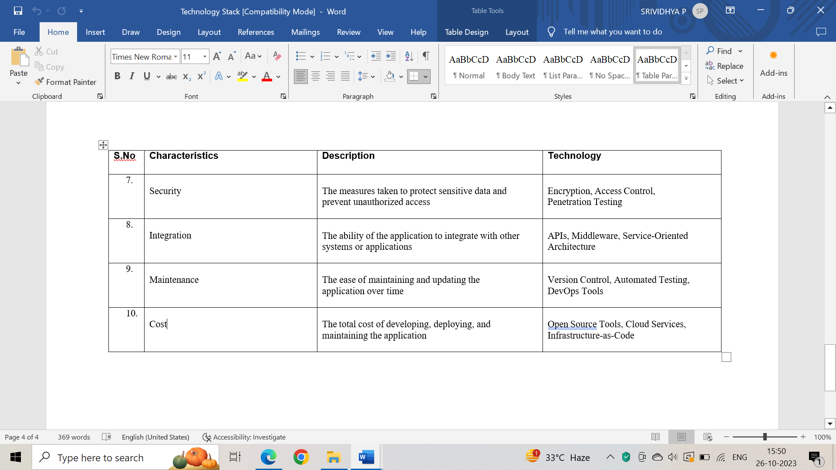

**PROJECT PLANNING & SCHEDULING**

**User Stories**

|  |  |  |  |  |  |  |  |  |  |  |
| --- | --- | --- | --- | --- | --- | --- | --- | --- | --- | --- |
| **USER TYPE** | **FUNCTIONAL REQUIREMENT** | **USER**  **STORY NUMBER** | **USER STORY/TASK** | **ACCEPTANCECRITERIA** | | | **PRIORITY** | | **TEAM MEMBER** | |
| travel enthusiast | Search functionality | US001 | As a travel lover, I want to search through several travel aggregator platforms to evaluate the costs and availability of hotels and flights in order to get the best offers for my journey. | 1. The investigation ought to assess how user-friendly and satisfying each aggregator's website or app is overall. It should evaluate features like navigation, sorting choices, and search filters to see which aggregator offers the best user experience. (br) 2. Each aggregator's search results should be analyzed for timeliness and correctness, as well as for how competitively priced they are in relation to other aggregators and direct booking possibilities.This would entail looking for additional costs and comparing the overall cost of packages that include lodging, airfare, and other travel- related services. or graph | | | High | |  | |
| budget- conscious traveler | Search and Comparison | US002 | As a budget- conscious traveler , I want to compare the fees and charges of different travel aggregators, so that I can find the most affordable option for my trip. | | 1 The report needs to evaluate and contrast the attributes and offerings made by each aggregator. This should include an examination of their search filters, booking options, payment methods, customer service, loyalty programs, and any other features that are relevant.   1. The report should examine each aggregator's pricing structure, including fees, commissions, and other charges. In addition, the report should compare the prices of comparable flights, hotels, and rental cars across aggregators. 2. identify any price differentials. | high | |  | |

**CODING & SOLUTION:**

**Feature 1 – FLASK APP PYTHON CODE**

The flask app code is used to deploy our project and gives us a http address to access our page.

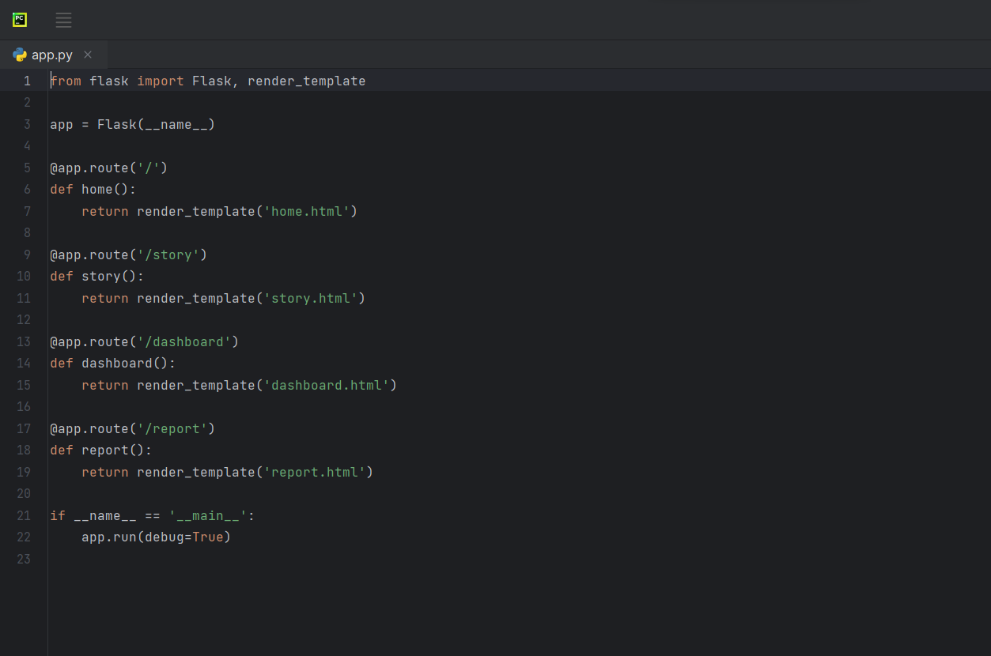

**OUTPUT:**

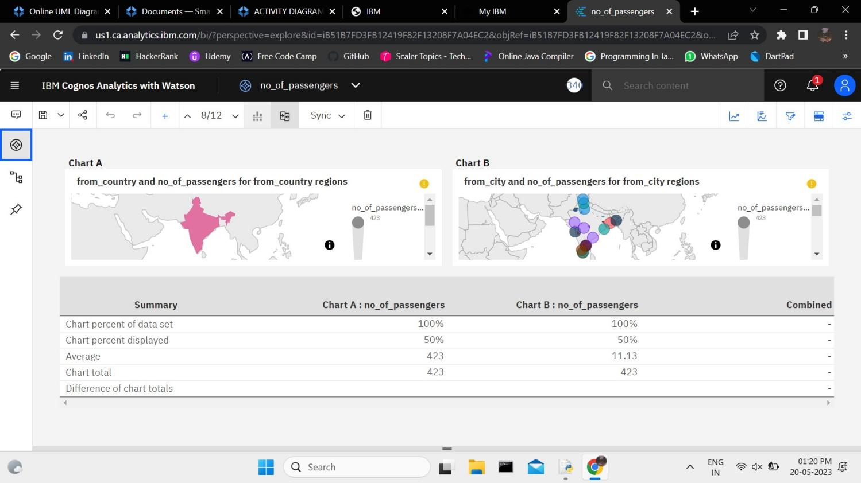

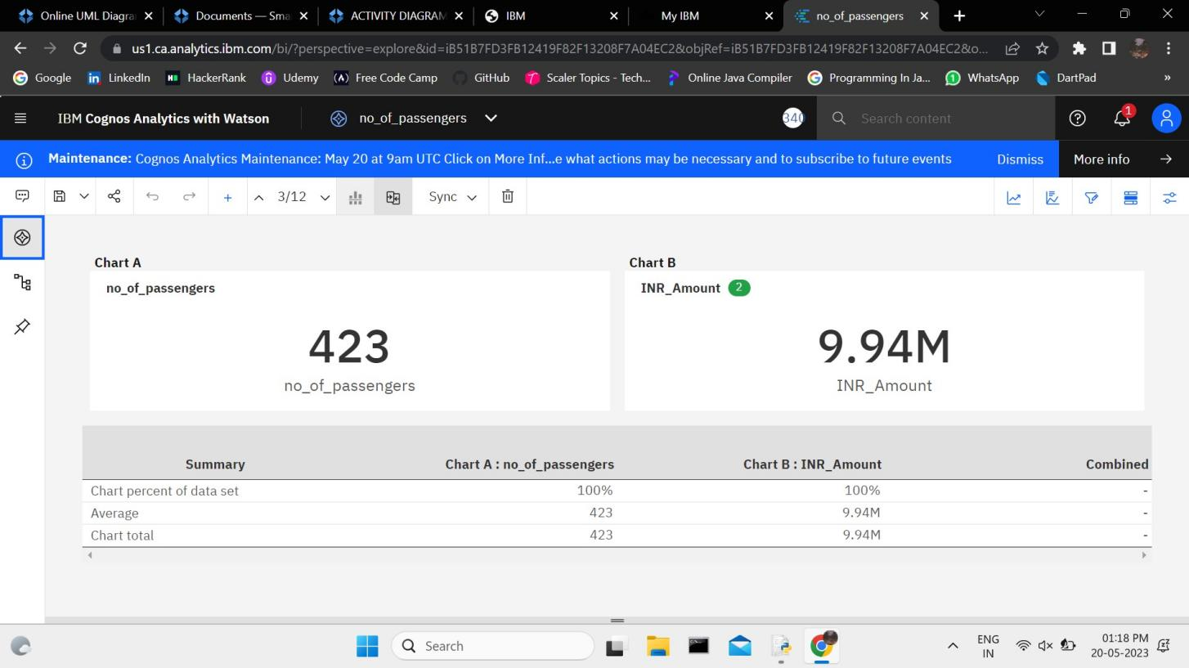

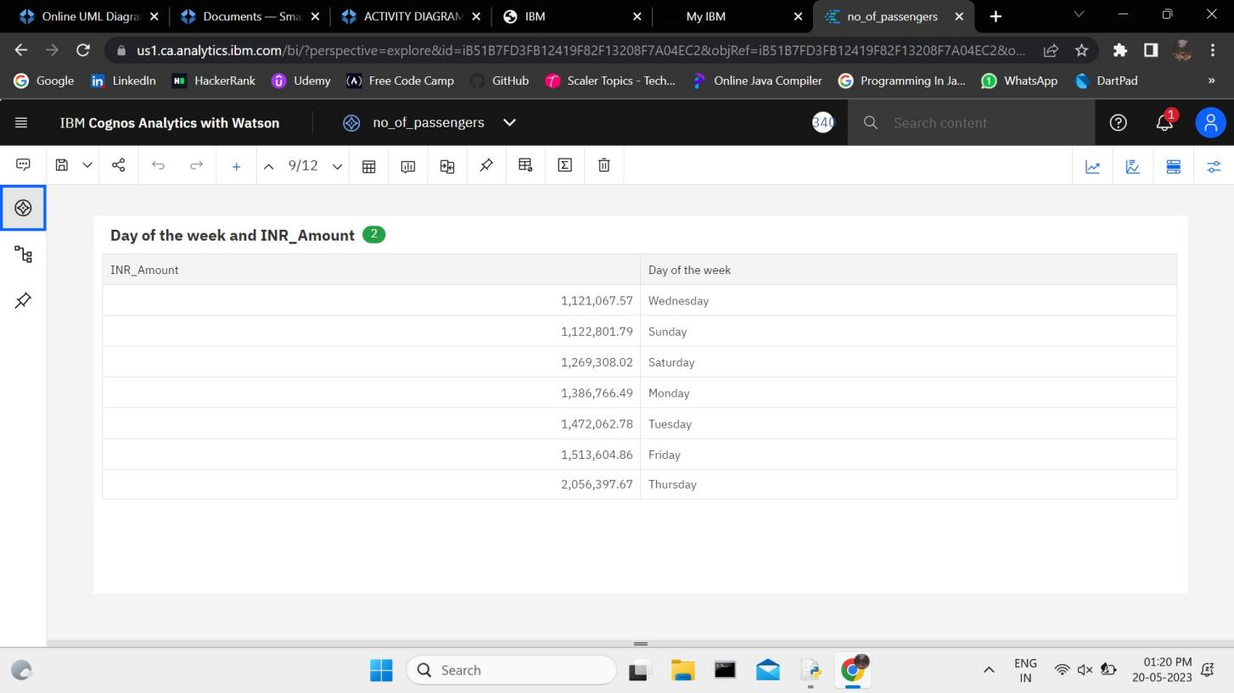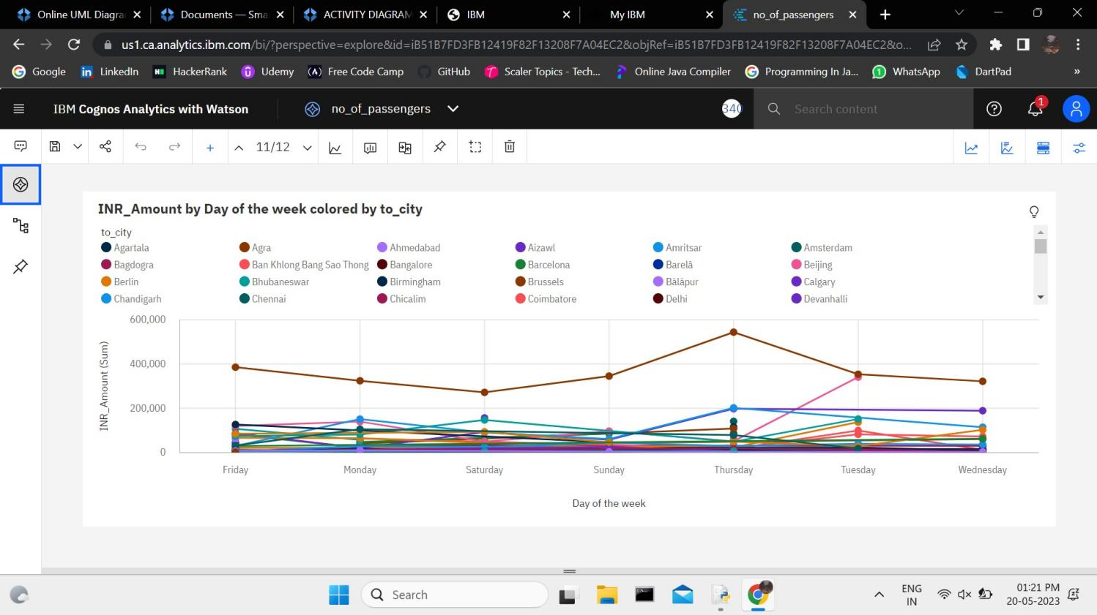

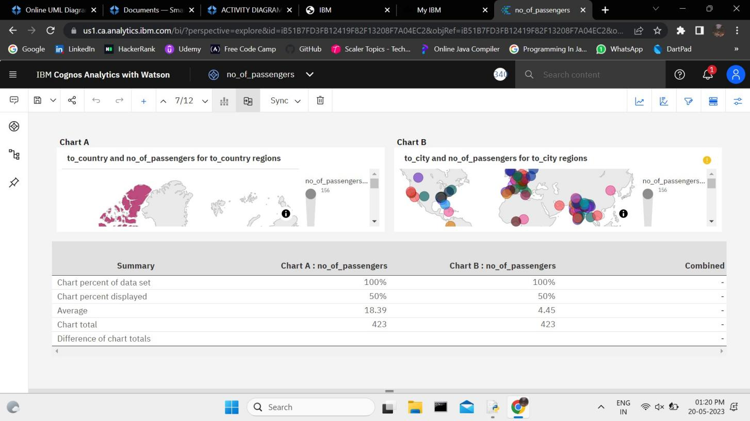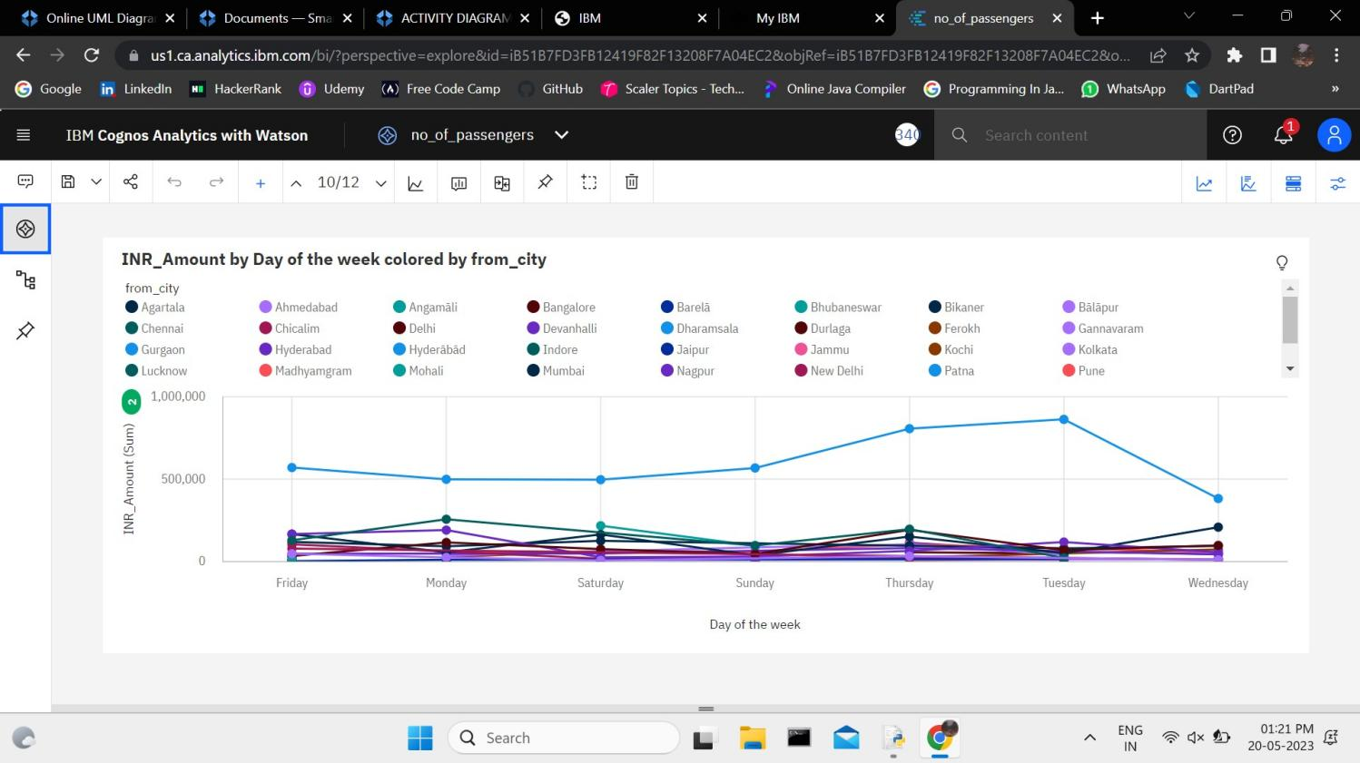

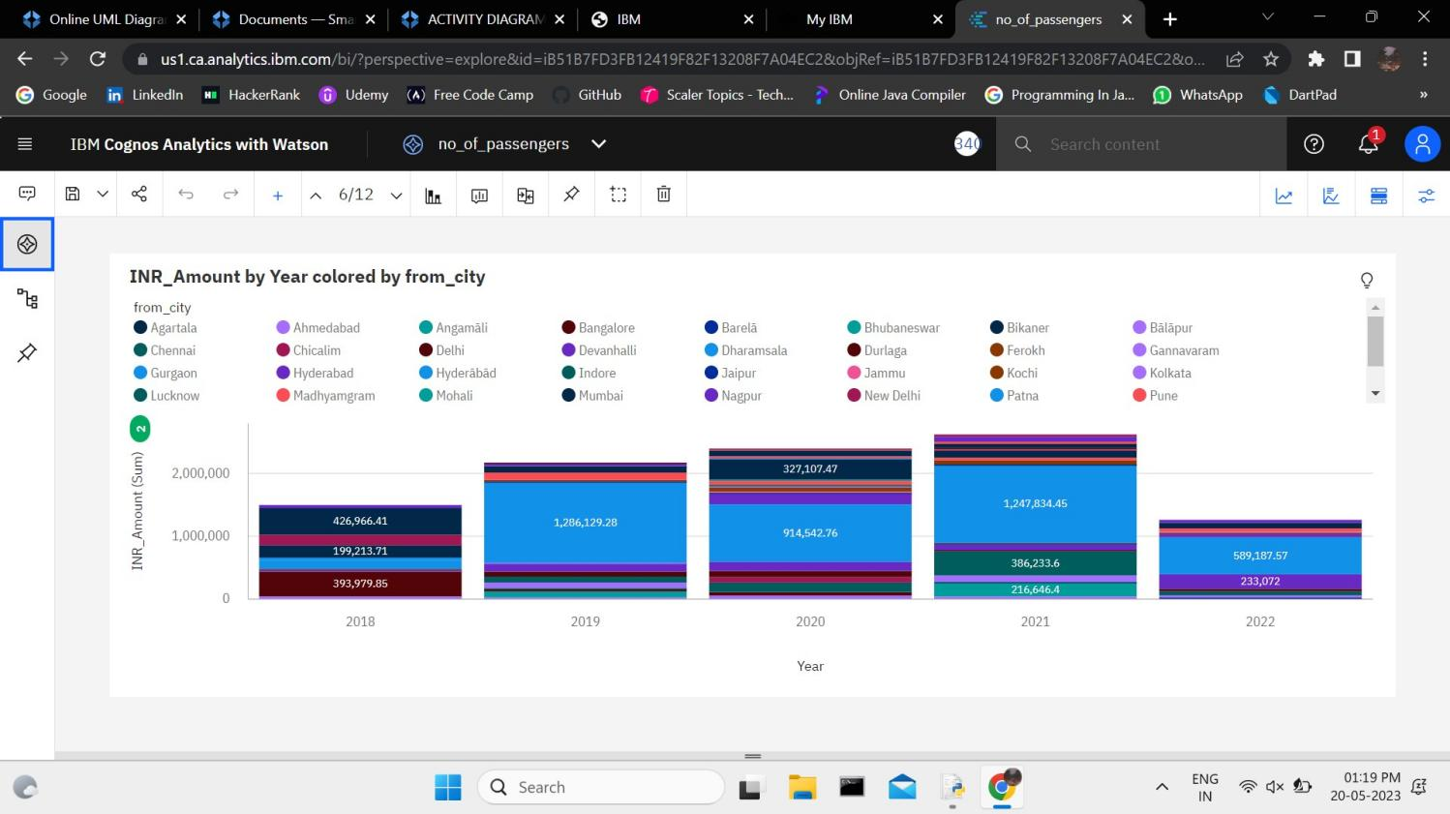

**HOMEPAGE:**

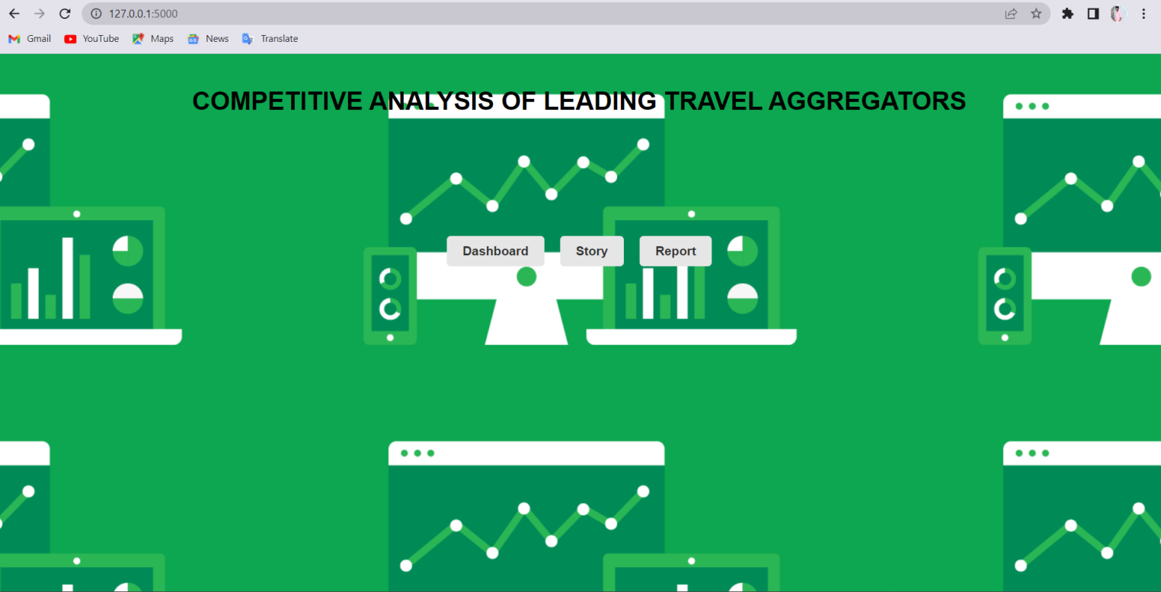

**DASHBOARD:**

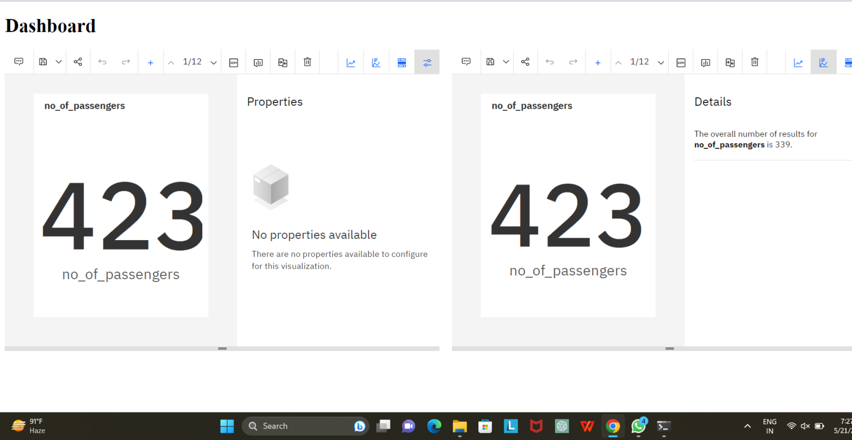

**STORY:**

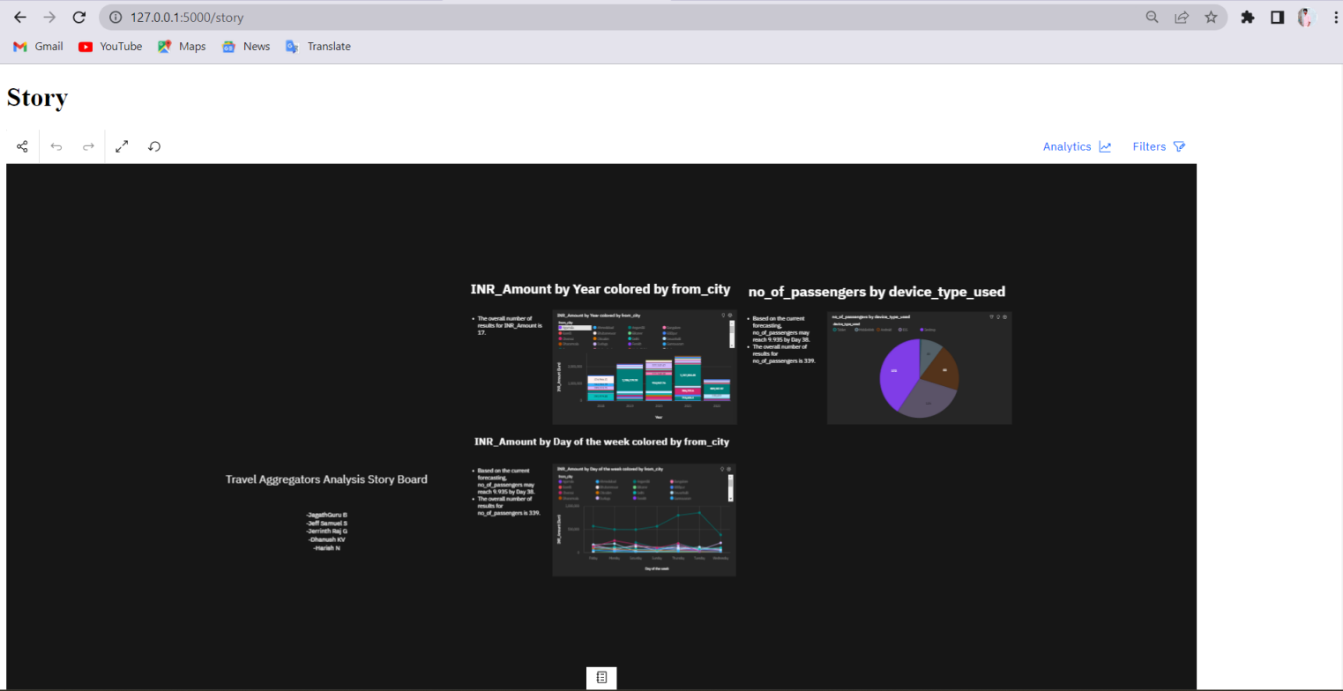

**REPORT:**

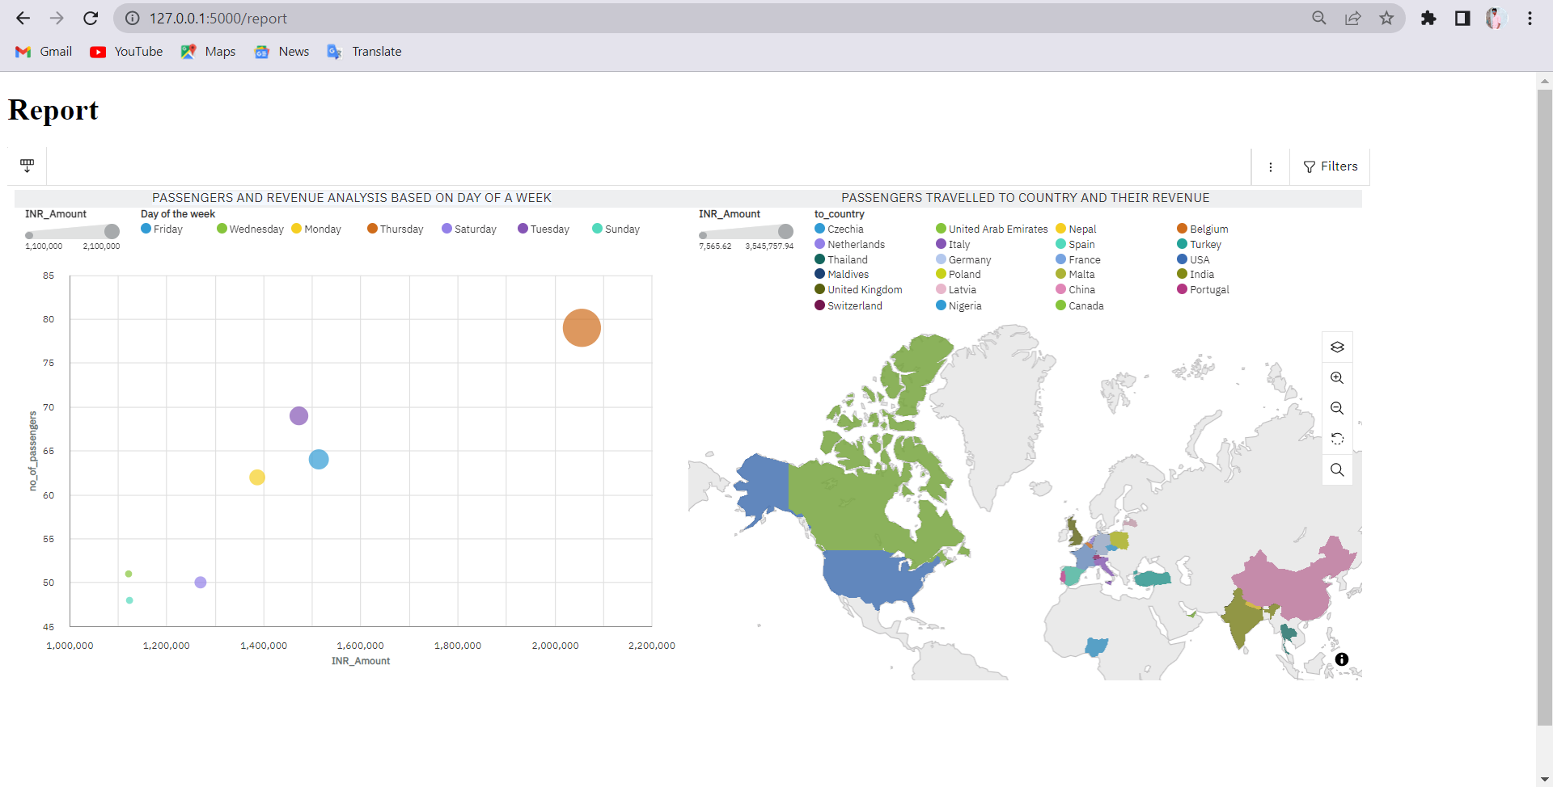

**TESTING:**

**TEST CASES:**

Creating test cases for a travel aggregator analysis project is crucial to ensure that the system functions correctly and meets its requirements. Here are some sample test cases that you can consider for such a project:

1**. Aggregation Accuracy Comparison**: Compare the results of your analysis with data from multiple reputable sources, such as individual travel websites or official tourism boards. Verify if the aggregated information, including prices, availability, and destination details, aligns with data from these sources.

2. **Price Comparison**: Choose a popular destination and compare prices for flights, accommodations, and car rentals from various travel aggregators. Ensure that the analysis effectively captures and presents the best deals, discounts, and price variations across different platforms.

3.**Destination Coverage Assessment**: Test the analysis's ability to encompass a wide array of destinations. Confirm that it covers both well-known tourist spots and more obscure, offbeat locations. Compare the results with established travel destinations to validate the analysis's comprehensiveness.

4**. Travel Package Analysis**: Evaluate the analysis's capacity to aggregate and compare complete travel packages, which include flights, accommodations, and activities. Ensure that it offers diverse options and accurately displays package prices, inclusions, and availability.

5. **Real-Time Updates Test**:Conduct a test to measure how quickly the analysis updates its data in response to fluctuations in prices, availability, or other pertinent information. Observe the analysis over a specified time frame and compare the results with real-time updates from individual travel websites.

6. **User Experience Evaluation**: Assess the usability and user interface of the travel aggregation analysis. Evaluate its ease of navigation, search features, filters, and sorting capabilities. Confirm that users can easily access the desired information and efficiently compare various travel options.

7. **Data Integrity Check**: Execute a test to ensure that the analysis doesn't present outdated or erroneous information. Confirm that the data, such as prices, availability, and reviews, is current and accurate.

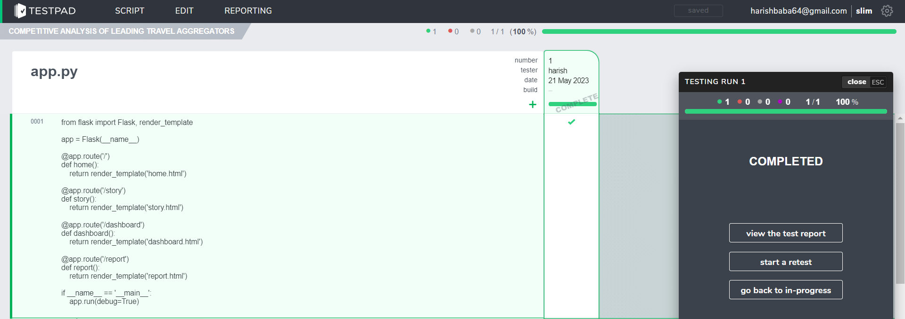

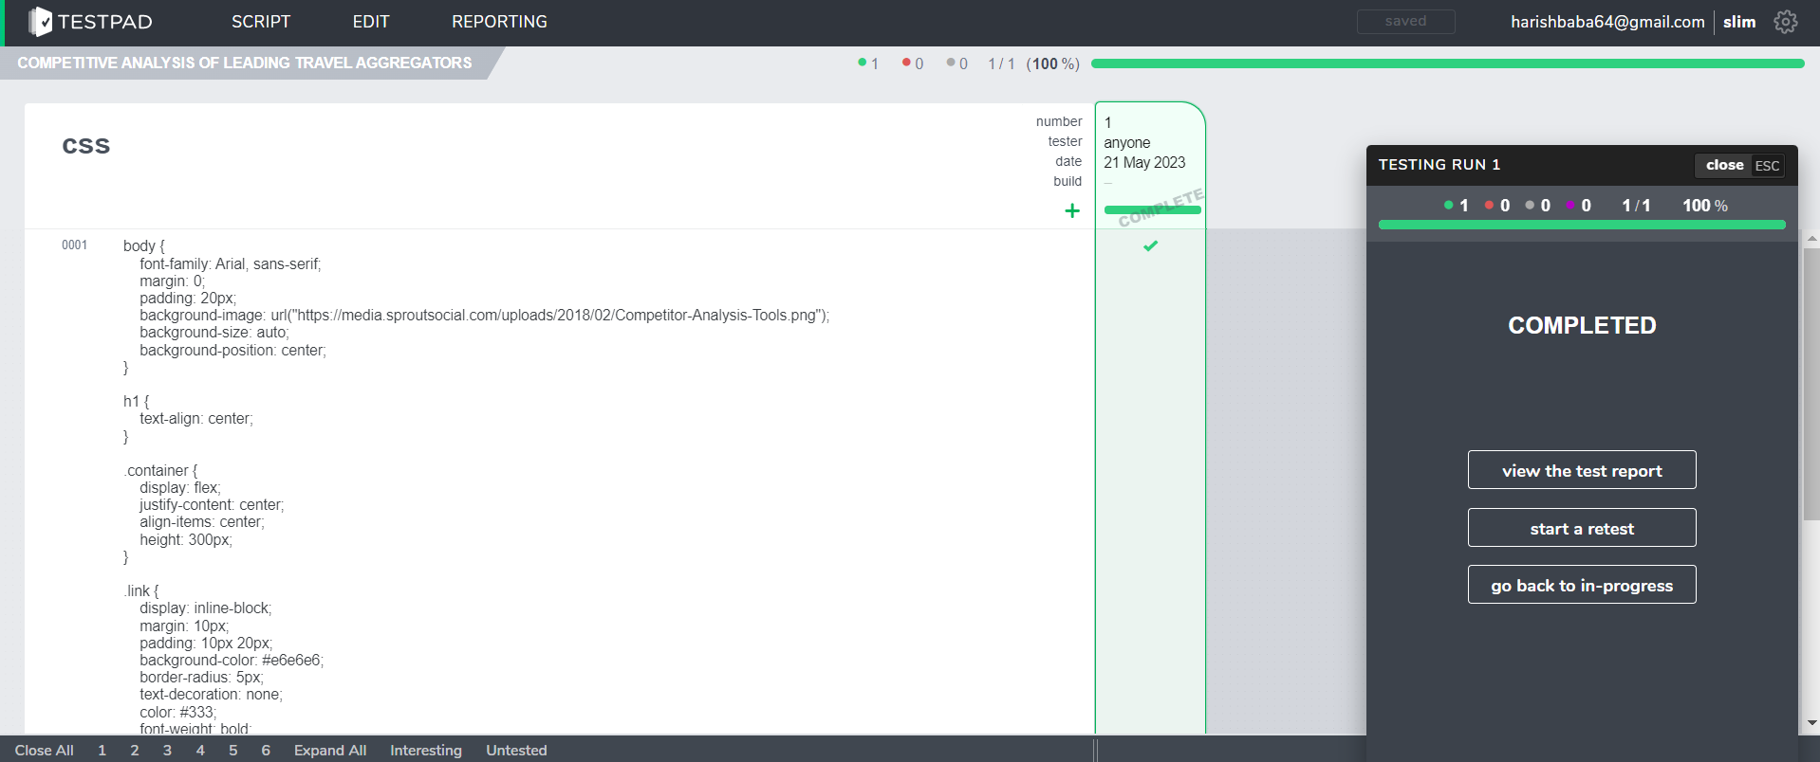

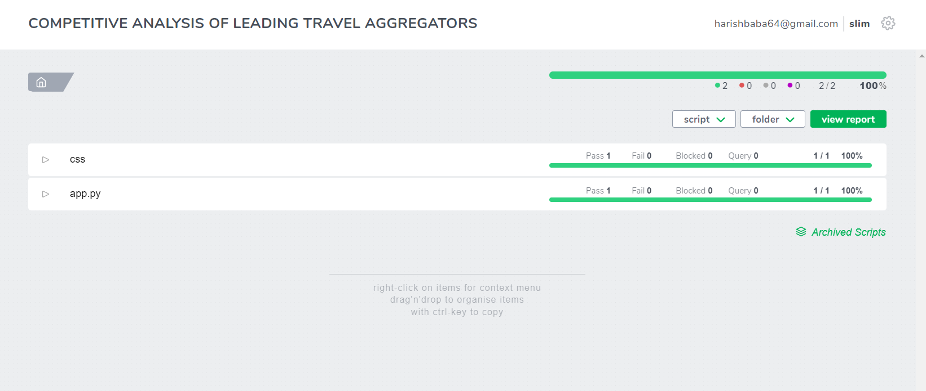

**PERFORMANCE METRICS:**

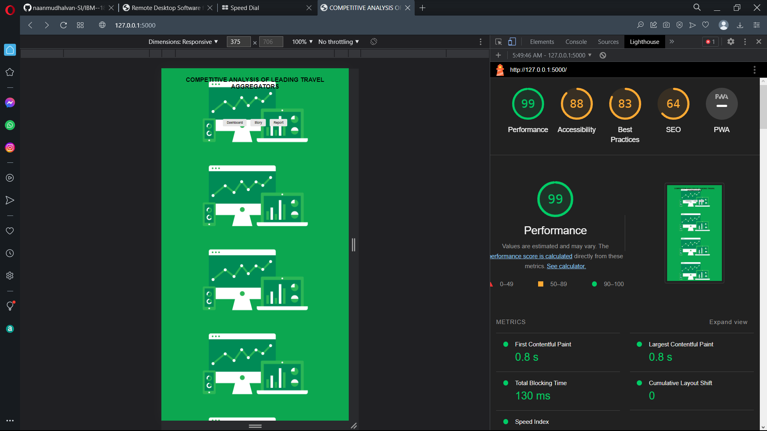

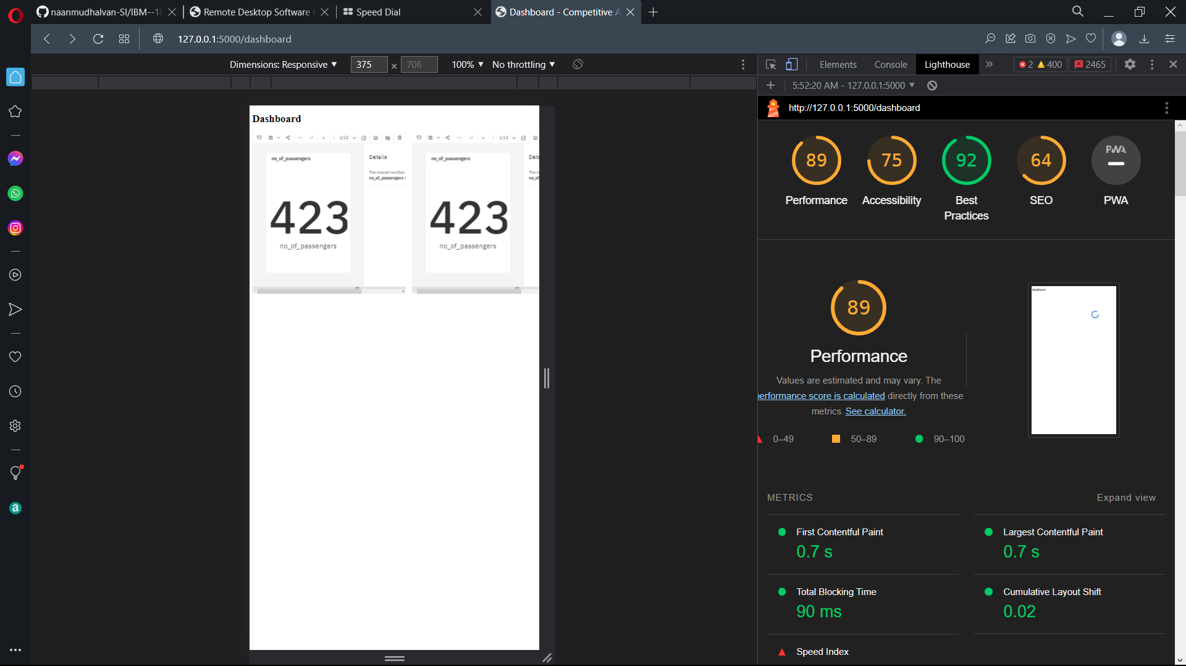

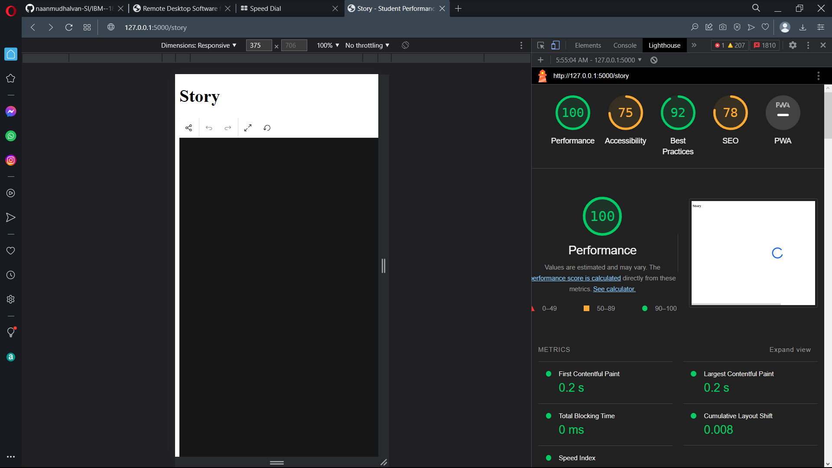

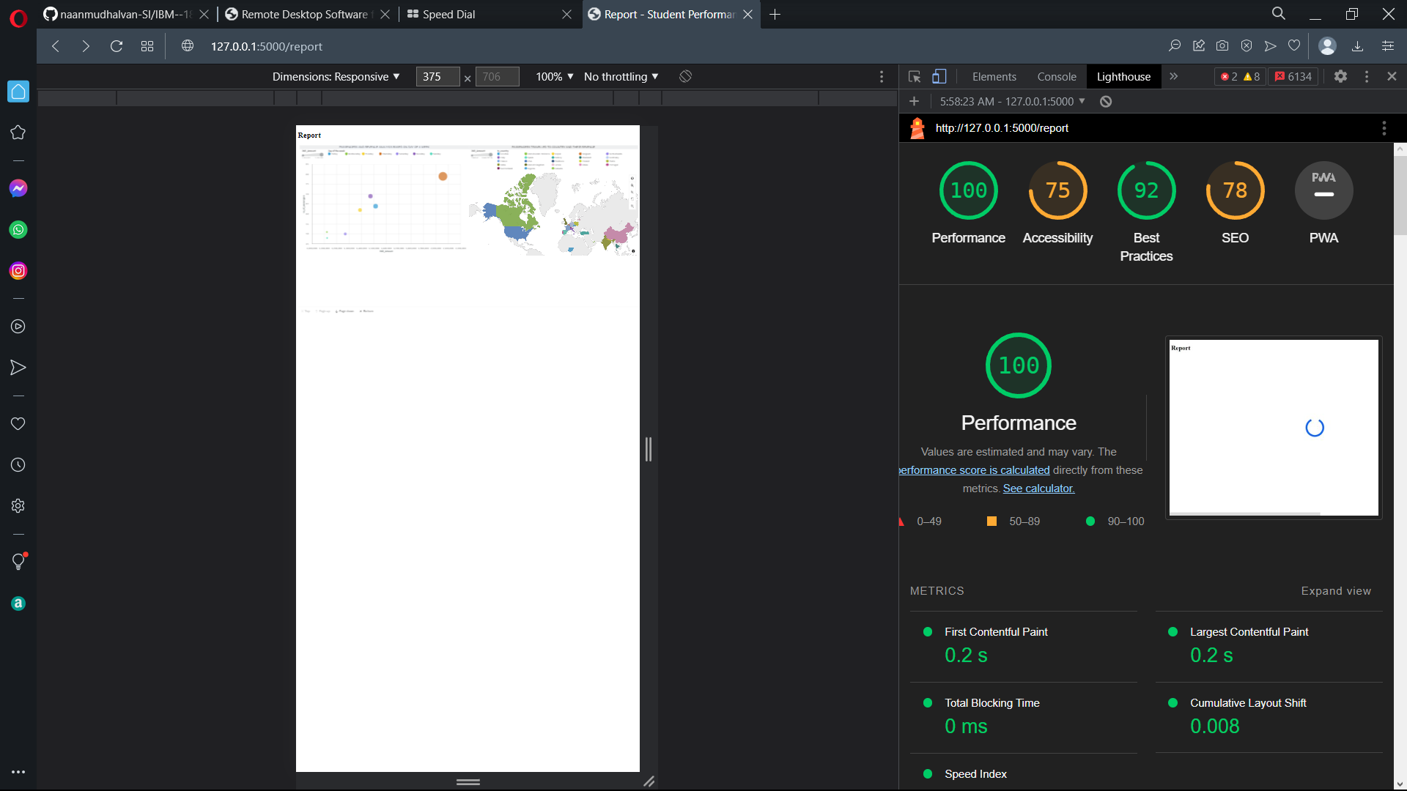

**ADVANTAGES & DISADVANTAGES:**

**Advantages of Travel Aggregators:**

1. **Convenience:** Travel aggregators offer a single location where you can look up, evaluate, and reserve a range of travel-related services. Because you don't need to visit several websites or make multiple phone calls to schedule different components of your trip, this convenience saves time and effort.
2. **Price Comparison**: Aggregators let you assess offers and rates from several suppliers. This aids in locating the most affordable rates for travel, lodging, and other services. It is frequently possible to view side-by-side comparisons, which facilitates decision-making.
3. **Access to a Vast Variety of Options**: Travel aggregators frequently collaborate with a large number of lodging establishments, airlines, and other service providers. This opens up a whole range of options for you to choose from, including affordable and luxurious solutions.
4. **User Reviews and Ratings:** For hotels, airlines, and other services, the majority of travel aggregators include user reviews and ratings. With this knowledge, you may steer clear of potentially negative situations and make better decisions.
5. **Discounts & Exclusive Deals**: Many travel aggregators negotiate exclusive deals with suppliers, giving you access to savings and unique offerings that might not be found elsewhere.
6. **Flexible Search Filters**: Aggregators frequently provide sophisticated search filters that let you tailor your search according to parameters such as location, star ratings, price range, and more. It is simpler to identify the ideal travel possibilities because to this flexibility.
7. **Booking Multiple Cities and Services at Once:** You can reserve several cities and services at once, for example, combining a flight, hotel, and rental vehicle into one all-inclusive trip. Planning intricate routes is simplified by aggregators.
8. **Customer Service:** A lot of travel aggregators provide customer service to help with problems, modifications, or cancellations related to reservations. They can also offer direction in the event that travel is disrupted.
9. **Mobile Apps:** Travel aggregators frequently offer easy-to-use mobile apps that let you plan and schedule your trips while on the go.
10. **Notifications and Alerts for Travel**: A few aggregators provide alert services for travelers, informing you of crucial developments such as gate changes and aircraft delays.
11. **Benefits & Loyalty Programs:** A few travel aggregators provide benefits for making reservations through their platform, either through partnerships with credit card issuers or through their own loyalty programs. This may result in free travel, money, or savings.
12. **Secure Payment choices**: Booking and paying for your travel services online is safe when using travel aggregators, which usually provide secure payment choices.

**Disadvantages of Travel Aggregators:**

1. **Service Fees and Commissions**: A few travel aggregators impose commissions or service fees on reservations. These charges can raise the total cost of your vacation and may not always be obvious right away.
2. **Limited Customization:** Although travel aggregators provide a large selection of possibilities, direct bookings with providers may offer greater flexibility. Booking directly with the service provider may be better appropriate for travelers with certain needs or preferences.
3. **Lack of Personalized Service:** Because travel aggregators are self-service platforms, you might not get the same amount of individualized support and customer service as you would if you made a direct reservation with a hotel or airline.
4. **Hidden Costs**: Not all fees, taxes, or surcharges may be disclosed up front by certain aggregators. When making a reservation, checking into a hotel, or boarding a flight, travelers may find out about extra expenses.
5. **Errors** in the booking process can result in inaccurate dates, destinations, or other information. Resolving such problems can be difficult and may necessitate extra expenses or alterations to your travel itinerary.
6. **Restricted Discount Availability**: Although travel aggregators might provide unique offers, it is possible that they don't always have access to all promos or discounts.
7. **Procedures for changes and cancellations**: Travel aggregators frequently have their own procedures for changes and cancellations, which may be more stringent than those of the service providers. It is crucial to comprehend the terms and restrictions.
8. **Overwhelming possibilities:** For certain passengers, the enormous selection of possibilities offered by travel aggregators may be too much to handle. Making decisions might be more difficult when there are several options to choose from.
9. **Assurance of Quality:** Although user reviews and ratings can be found on aggregators, their dependability and quality can differ. Reviews should always be regarded with a grain of salt because they can occasionally be biased or manipulative.
10. **Security Issues:** Making reservations on websites run by third parties may give rise to security issues. It is imperative to guarantee the security of the aggregator's website and the privacy of your money and personal data.

**CONCLUSION:**

In conclusion, the way we book and arrange our vacation has been completely transformed by travel aggregators. These internet resources are incredibly convenient since they offer a single point of contact for comparing and reserving hotels, airlines, and other travel-related services. Travelers gain from being able to access a wide range of options, get the best bargains fast, and base their judgments on user feedback. Furthermore, a lot of aggregators obtain exclusive deals and discounts, which could save time and money.

But there are disadvantages to take into account. The total cost may increase due to service fees and commissions, unstated expenses, and perhaps onerous cancellation policies. Some passengers may not always receive the degree of customisation and individualized care that they want from aggregators, and conflicts may be more difficult to settle. However, the benefits of travel aggregators—such as convenience, cost savings, and choice—far outweigh the drawbacks for a large number of people. Understanding travel aggregator terminology, contrasting their offers with those of service providers, and giving careful thought to each person's unique travel requirements and preferences are essential to getting the most out of them. In the end, travel aggregators have developed into a vital resource for contemporary tourists, simplifying the reservation procedure and providing a vast range of choices at their disposal

**FUTURE SCOPE:**

Travel aggregators have a bright future ahead of them thanks to developing technology, shifting customer tastes, and the travel industry's continuous expansion. The following are some important areas where future developments are likely to occur:

1. **Improved Mobile Apps:** With their enhanced functionality, real-time updates, and seamless integration of several travel services, mobile apps will remain a primary focus for travel aggregators.
2. **Integration of Cryptocurrency Payments**: To enable safe and borderless transactions, several travel aggregators may accept cryptocurrencies as a form of payment.
3. **Multi-modal travel booking:** Aggregators will incorporate other forms of transportation, such as buses, trains, and rideshares, into their offerings, going beyond simple bookings for flights and accommodations.
4. **Blockchain for Booking and Security:** By decreasing fraud and simplifying the booking process, blockchain technology can enhance transaction security and transparency. Refunds and insurance claim processing are only two of the travel-related tasks that smart contracts can automate.
5. **Artificial Intelligence (AI):** Travel aggregators will increasingly use artificial intelligence (AI) to deliver more tailored suggestions that take into consideration individual preferences and historical travel behavior. This will improve user experience.

**APPENDIX :**

**GITHUB:**

<https://github.com/Shivani3072/Naan-Mudhalvan>

**PROJECT DEMO LINK:**

[Demo video.mp4 - Google Drive](https://drive.google.com/file/d/1WP3umJLj3ivEbXrZ2adZQ2TGLg8o0tOA/view)